[1ST PAGE] - TEST SCENARIO: VERIFY REQUIREMENTS REVIEWS
Module Name: Requirement Review
Test Case ID: TC_01
Test Scenario: Verify Requirements Reviews
Verification and walkthrough of requirement documents and inspection activities for the Student Management System (SMS Application).
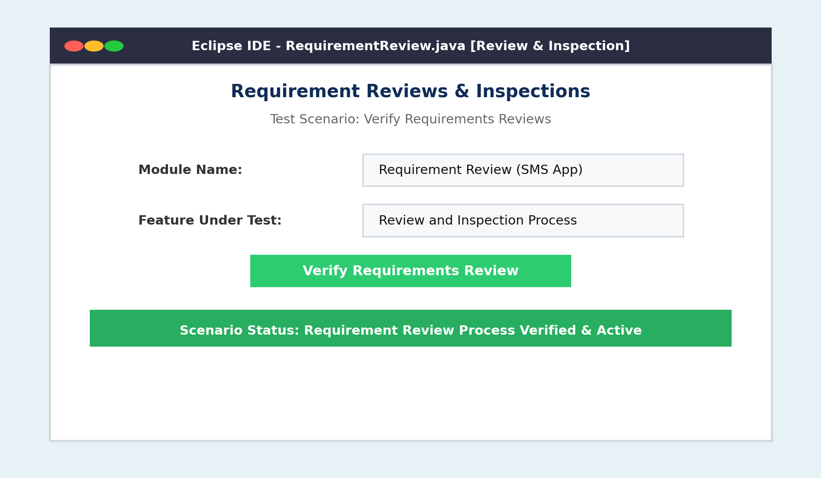

[2ND PAGE] - TEST OBJECTIVE: CHECK REQUIREMENTS CORRECT AND COMPLETED
Test Objective: Check Requirements Correct and Completed
Target Requirement: User Login Module
Quality Criteria: Zero Ambiguity & Full Completeness
Auditing functional requirement specifications to ensure all business rules are correct, complete, and free from ambiguity.
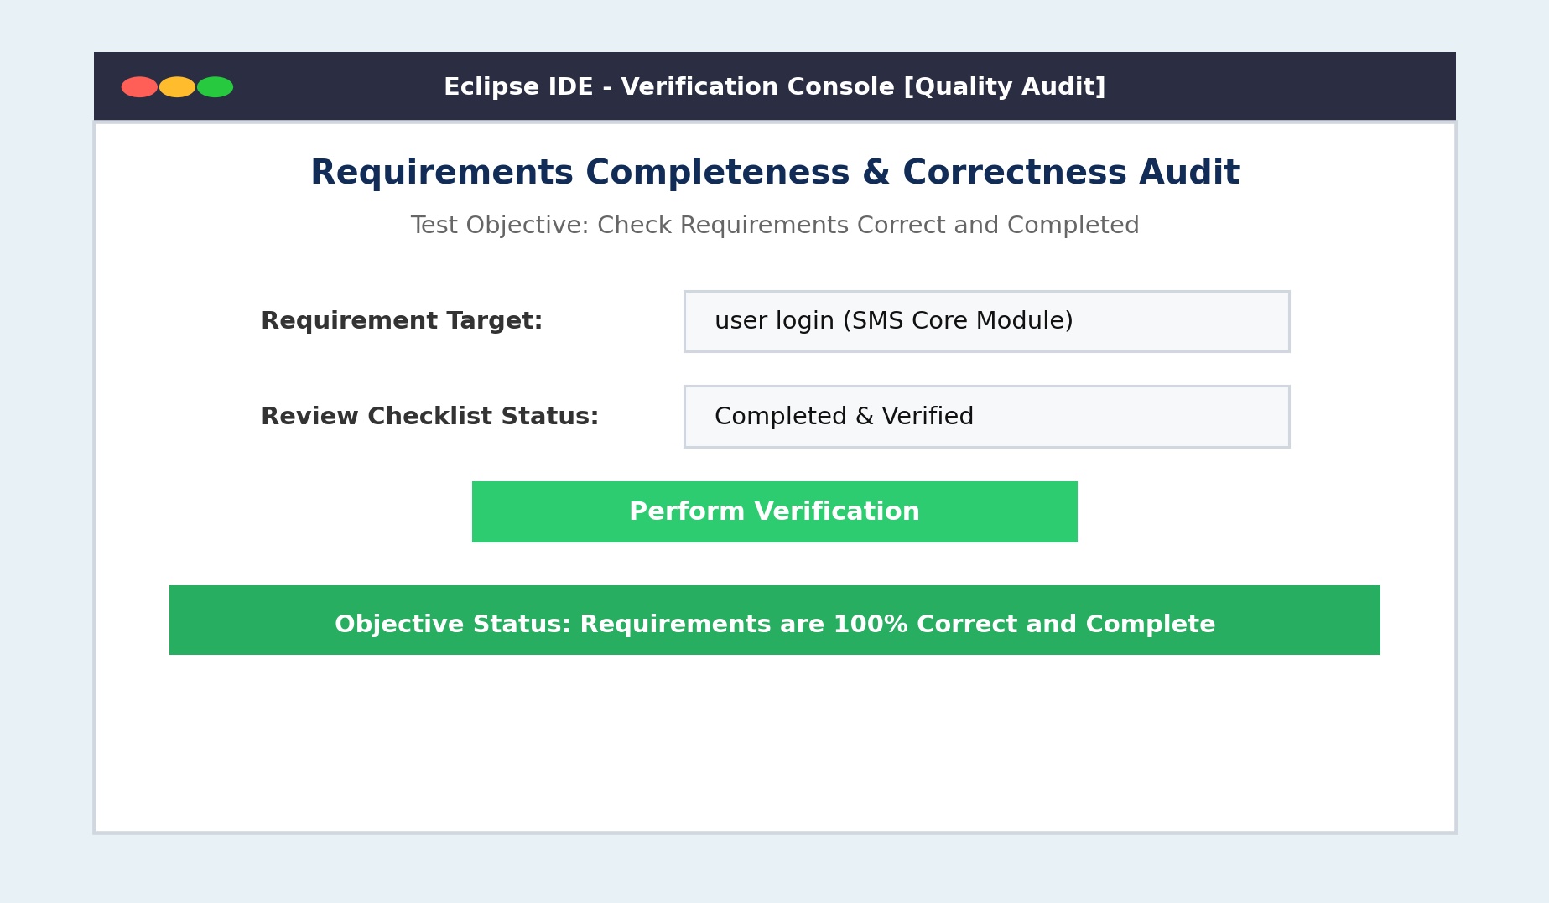

[3RD PAGE] - TEST TYPE: SYSTEM TESTING
Test Type: System Testing (Functional & Static Review)
Test Technique: Black Box Testing / Inspection
Priority / Severity: High / Medium
Executing system testing, black box inspections, and static analysis on requirement specification artifacts.
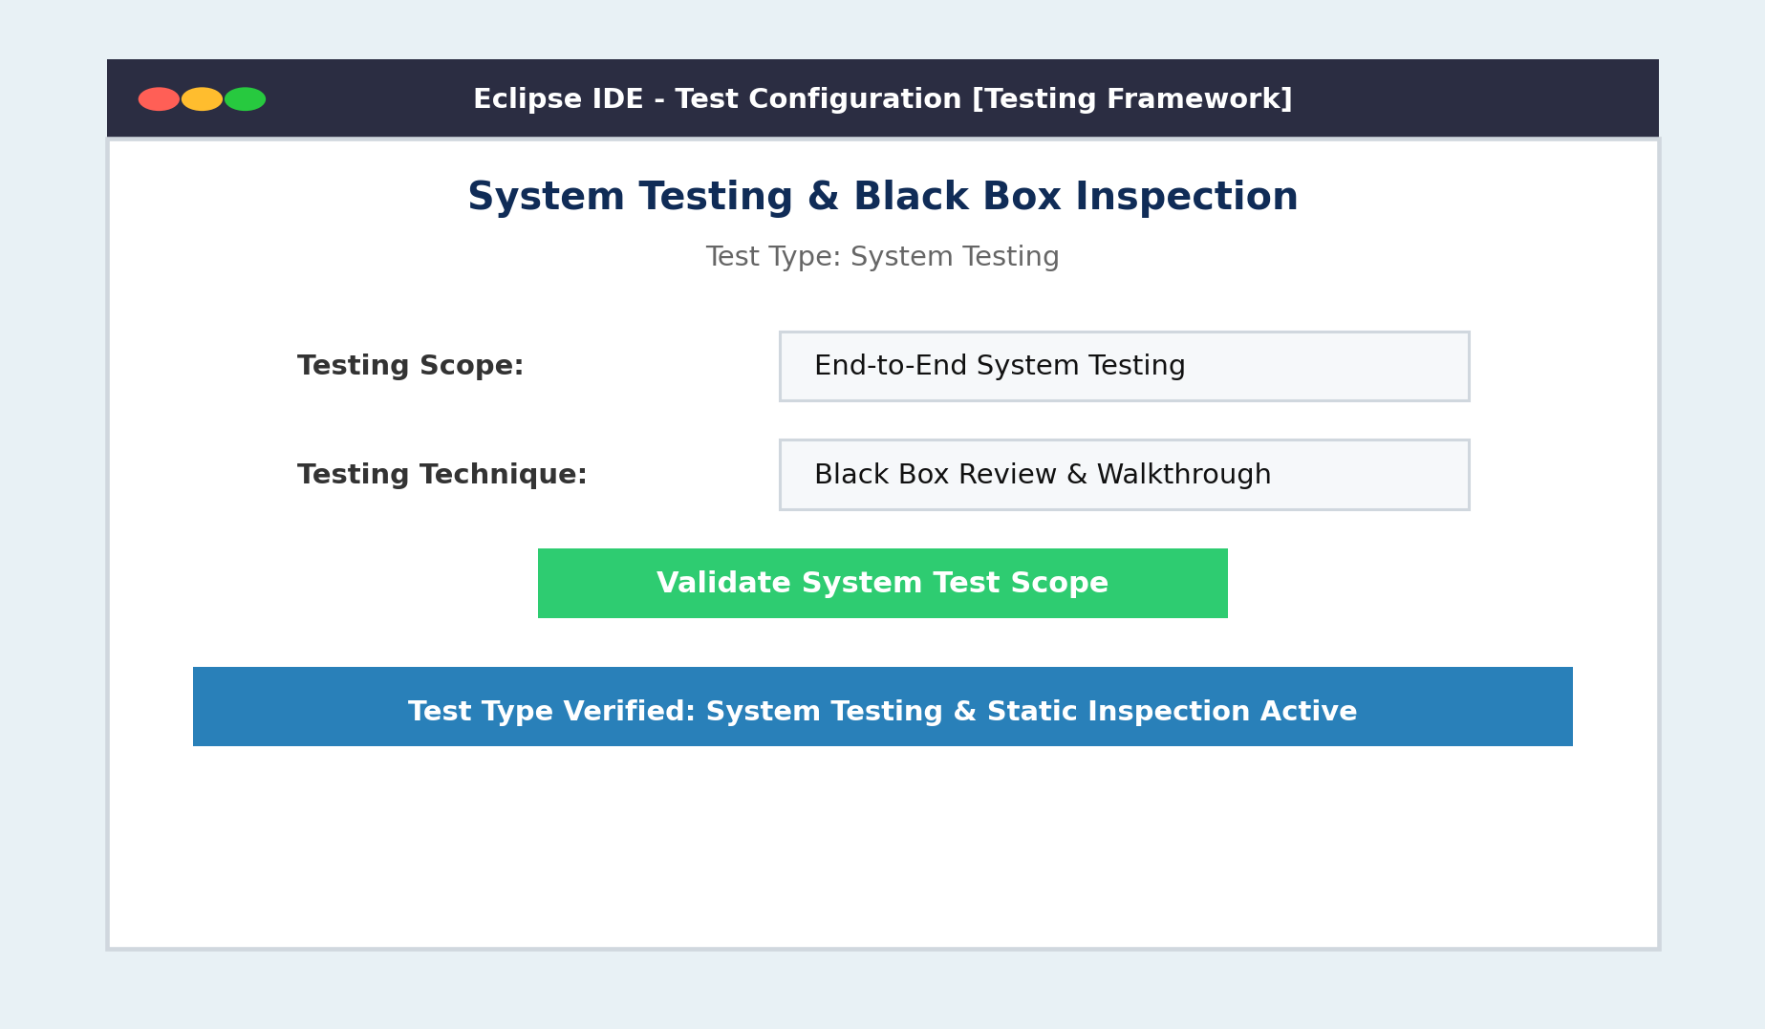

[4TH PAGE] - PRECONDITION: REQUIREMENTS DOCUMENTS AVAILABLE
Precondition: Requirements Documents Available
Available Artifacts: SRS Document & Review Checklist
Readiness: Verified & Accessible
Verifying that the Software Requirement Specification (SRS) document and review checklist are fully available prior to execution.
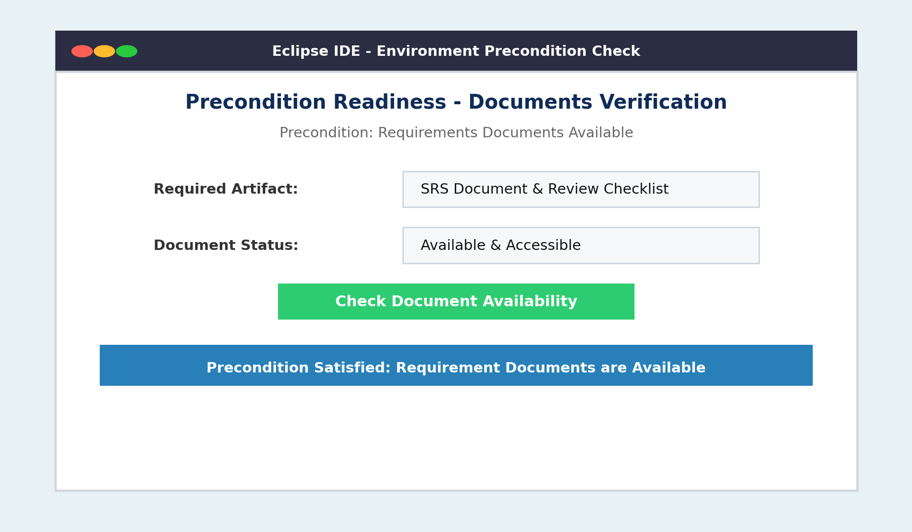

[5TH PAGE] - TEST ENVIRONMENT: JAVA ECLIPSE WINDOWS 11
Test Environment: Java, Eclipse IDE, Windows 11
IDE / Tools: Eclipse IDE for Java Developers
Operating System: Windows 11
Configuration of execution environment including Java JDK, Eclipse IDE workspace, and Windows 11 platform.
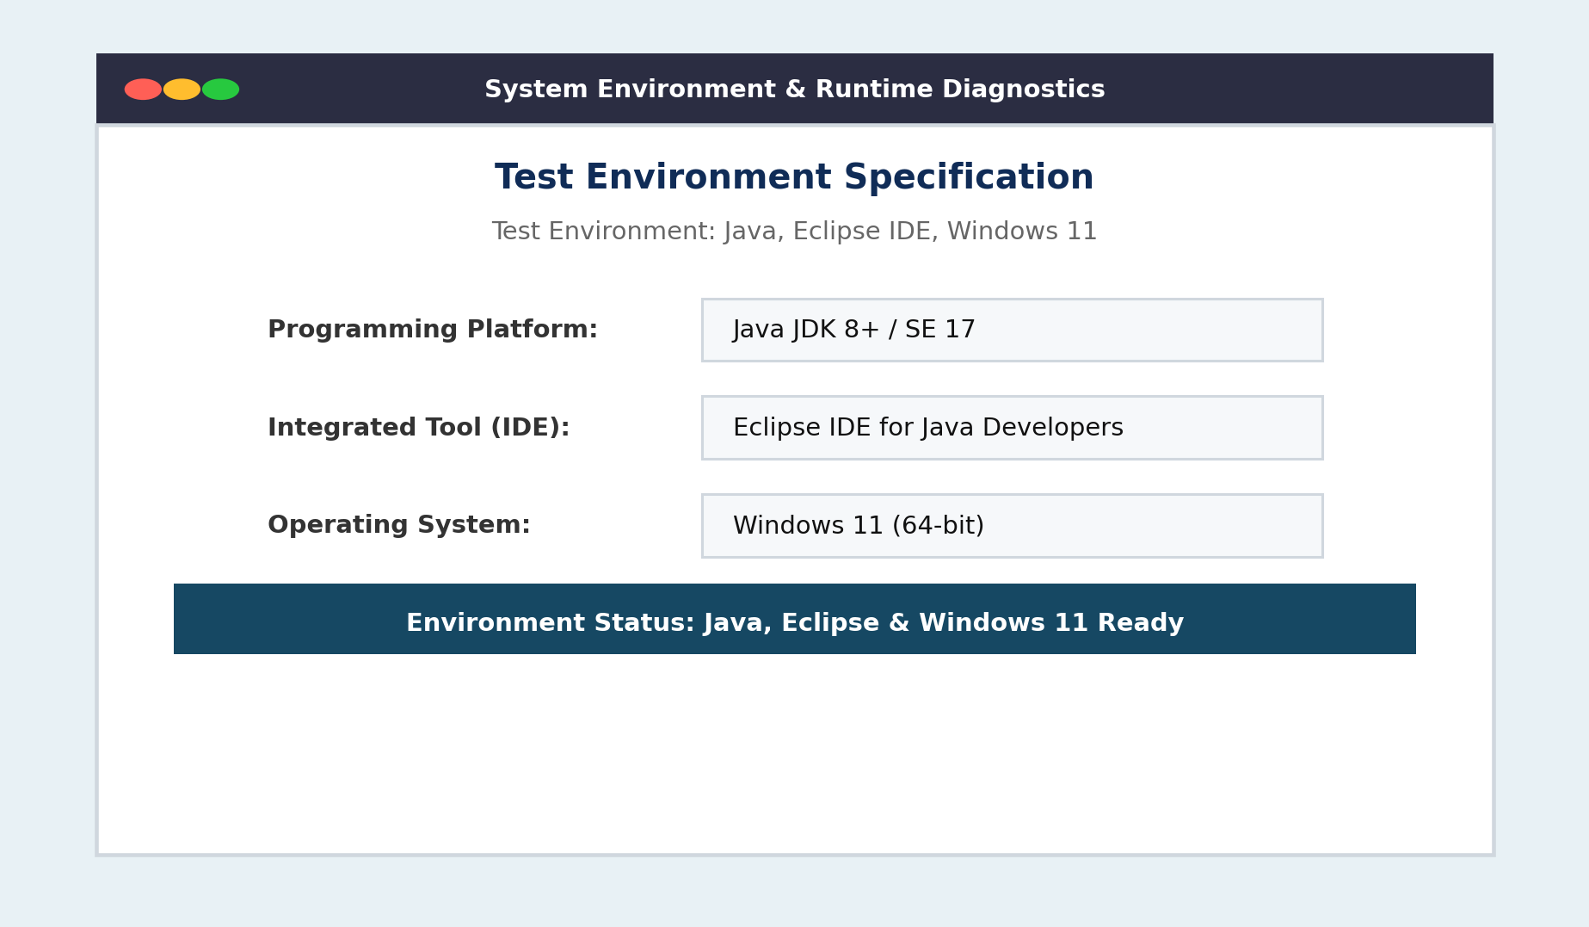

[6TH PAGE] - EXPECTED RESULTS: REQUIREMENTS REVIEWED SUCCESS
Expected Result: Requirements Reviewed Success
Actual Result: Requirement Reviewed Success (No Critical Defects Found)
Program Output: Requirement: user login | no critical Defects Found
Validation that the requirement inspection executes successfully, outputting requirement verification with no critical defects found.
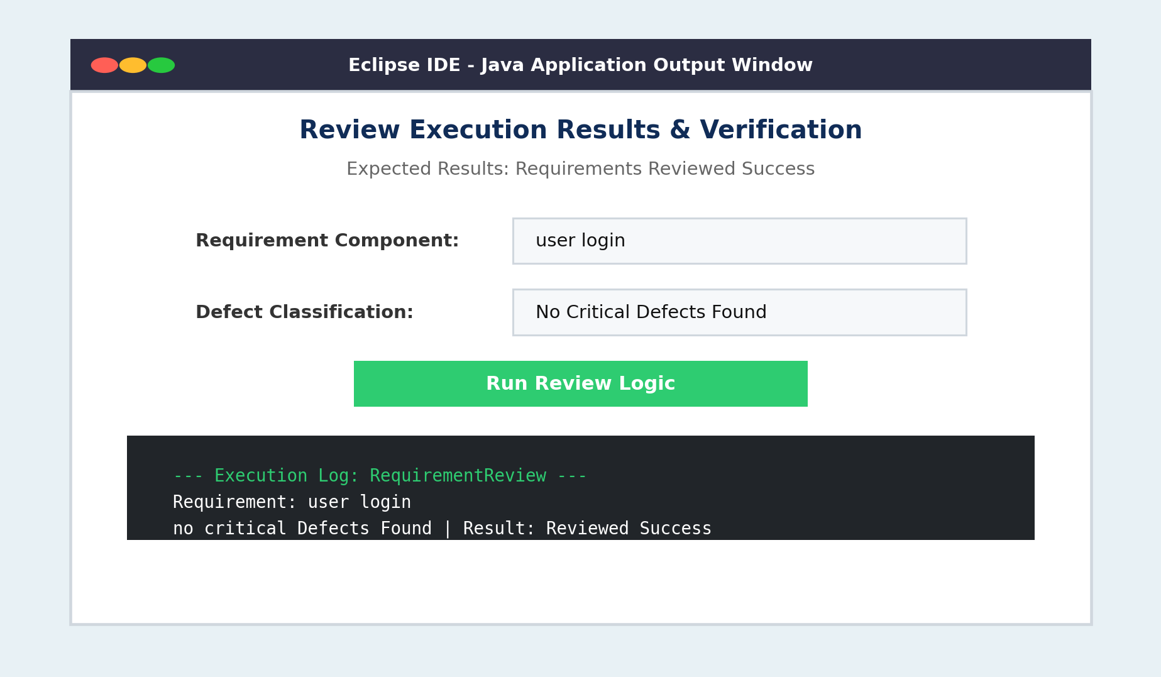

[7TH PAGE] - STATUS (PASS/FAIL): PASS
Test Case Status: PASS
Execution Result: Passed without Defects
Executed By: Student (Prajeet)
Final test closure verification confirming all criteria are met, results matched expectations, and sign-off status is Pass.
